1. **Please donot modify this template but create separate answersheet without this text.**
2. The name of SQL Answer document must be in following format:
3. **For assignments :*SQL_Assignment_<no of assignment>_ <your firstname> <your Lastname>.docx***

**E.g. SQL_Assignment_01_Swapnil Deshmukh.docx**

1. **For Practical: *SQL_LAB_<no of Lab>_ <your firstname> <your Lastname>.docx***

**E.g. SQL_LAB_01_Swapnil Deshmukh.docx**

1. **For Project: create only one document for all answers with document name format: *SQL_Project_01_<your firstname> <your Lastname>.docx***

**E.g. SQL_Project_01_Swapnil Deshmukh.docx**

1. Please do not write/repeate text of question itself.
2. Please donot use comments in the SQL code.

E.g. instead of Select * from Employee --select all columns from table **X**

Just keep Select * from Employee **√**

1. Answers in these documents should be in following format
2. ***Q<question no><sub Question no><sub-sub Question no>: ANS: <your answer in text without any formatting from MS word> <image of output>***

Like shown in example below.

1. If you don’t want to answer any question please mention its no. in prescribed format above with blank answer. Like in the example below

**For example,**

**you don’t know answer for question 5a, subquestion 1, It will be written as below**

Q5A1: ANS:

**Answer for question 1 will look like below**

Q1: ANS:

SELECT * FROM INFORMATION_SCHEMA.COLUMNS WHERE TABLE_NAME = 'MGR_HISTORY'

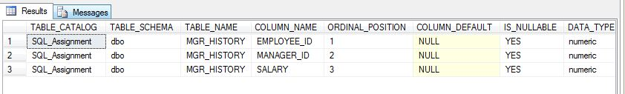

**Answer for question 7a sub-question 1 will look like below**

Q7A1: ANS:

SELECT EMPLOYEE_ID,HIRE_DATE,SALARY,MANAGER_ID

FROM EMPLOYEES

WHERE EMPLOYEE_ID < 120

